## In the AWS Console, select the “Oregon” Region and Select “Launch Instance”Macintosh HD:Users:cjohnson:Box Sync:cloudavail-awstraining:aws-intro:exercises:assets:Step 0 - EC2 Launch Instance.png

## Choose the “Ubuntu Server 14.04 LTS” AMI:

Note: feel free to select another AMI if desired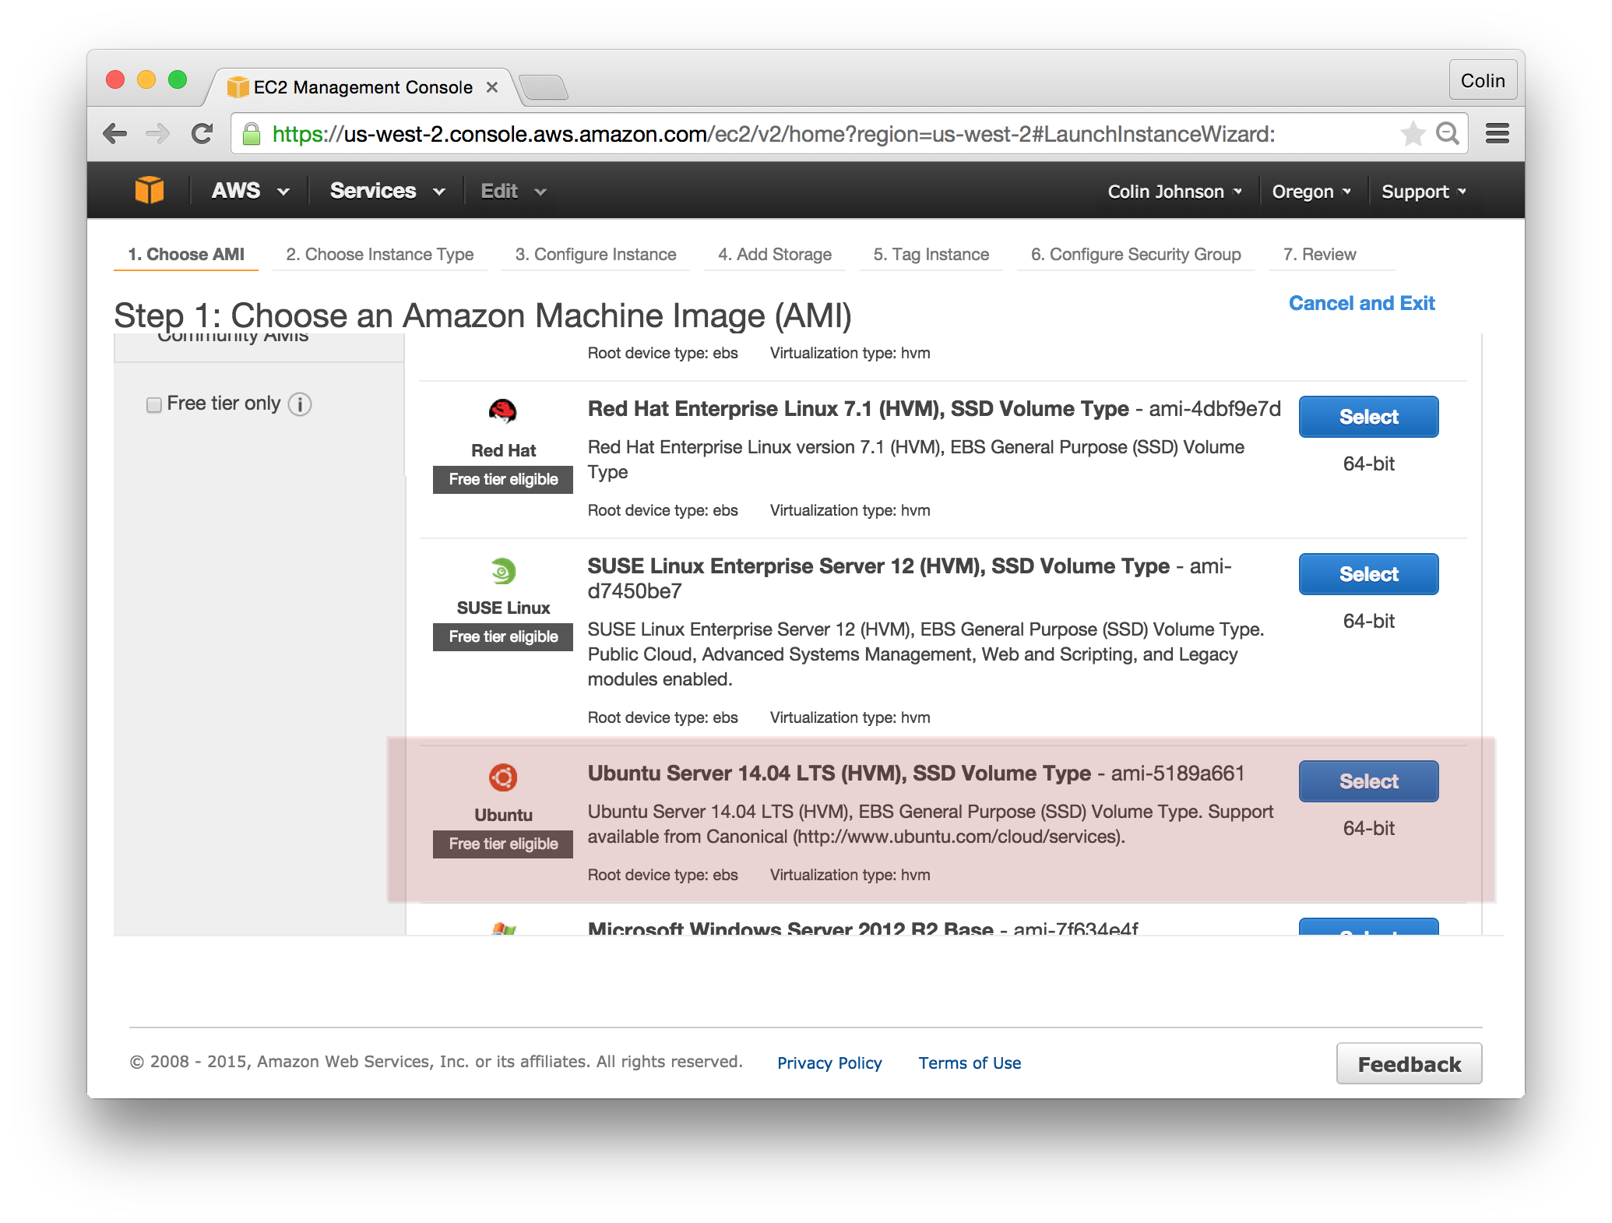

## Choose an Instance Type:

Note: instance types vary in performance and in cost. I prefer the t2.micro for testing, as it is the lowest cost instance.

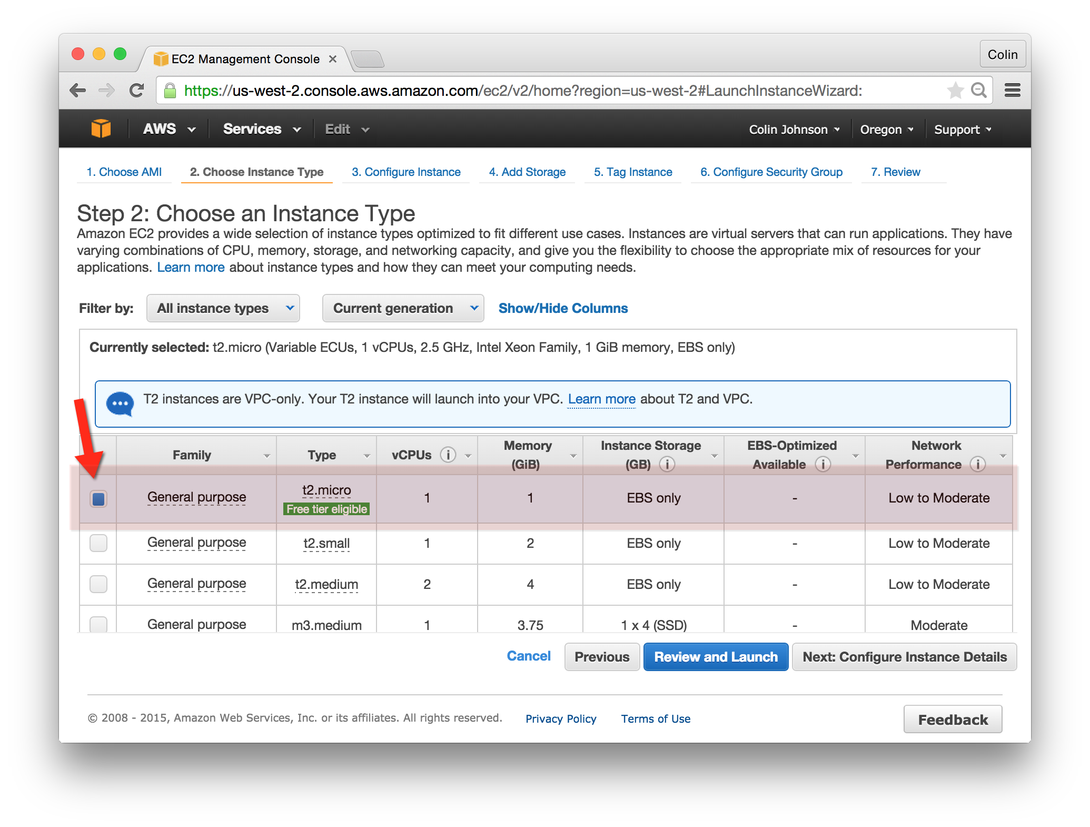

## Configure Instance Details:

Note: ask the presenter for the VPC ID and Subnet. The “Auto-assign Public IP” setting should be “Enabled.”

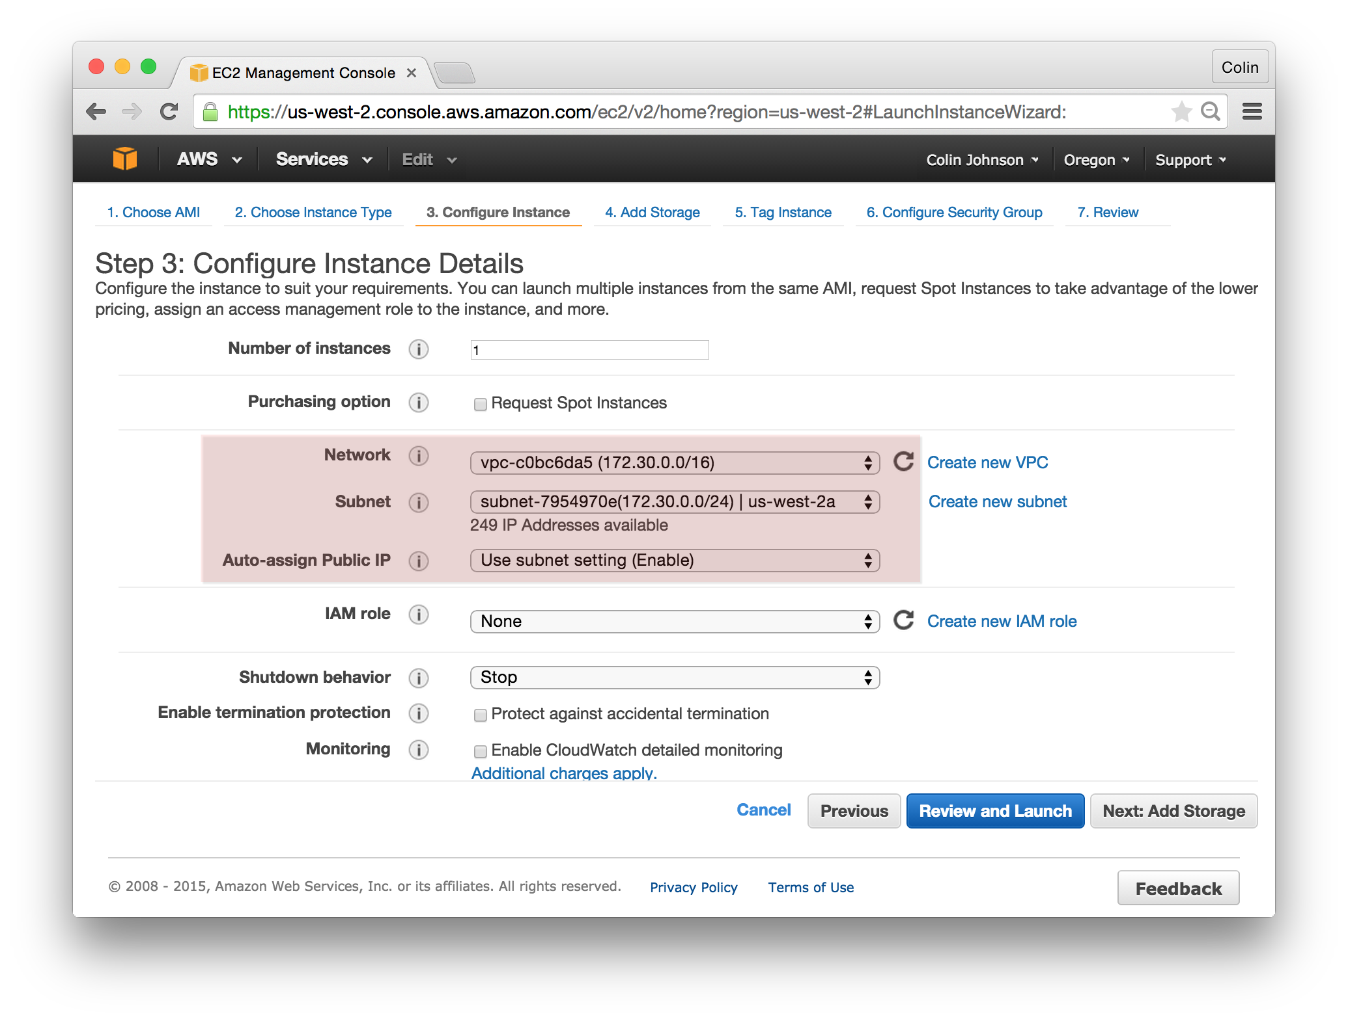

## Add Storage:

Storage can be resized or added at a later time. For now, select “Next: Tag Instance.”

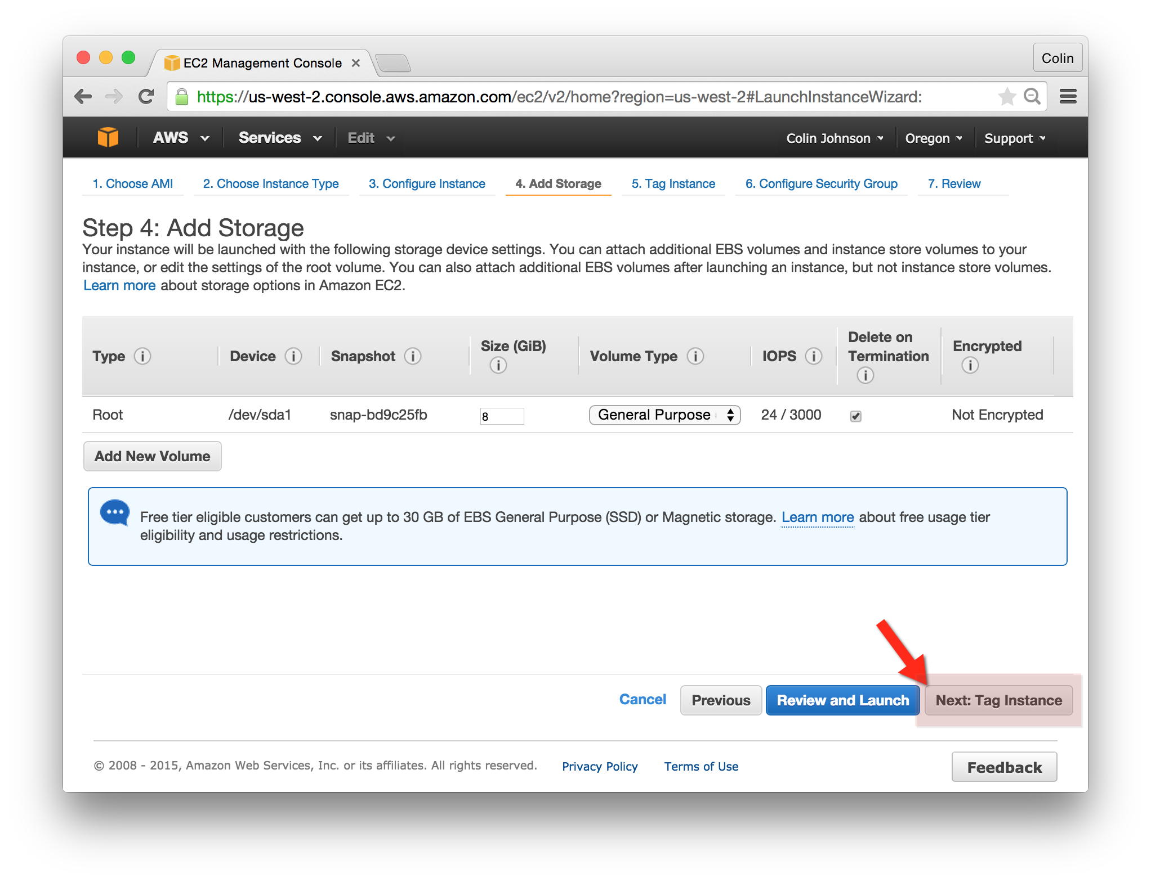

## Tag Instance:

Tags can be added at a later time, but people commonly forget to do this. Tag your instance with the value “www-yourname” now and click “Next: Configure Security Group.”

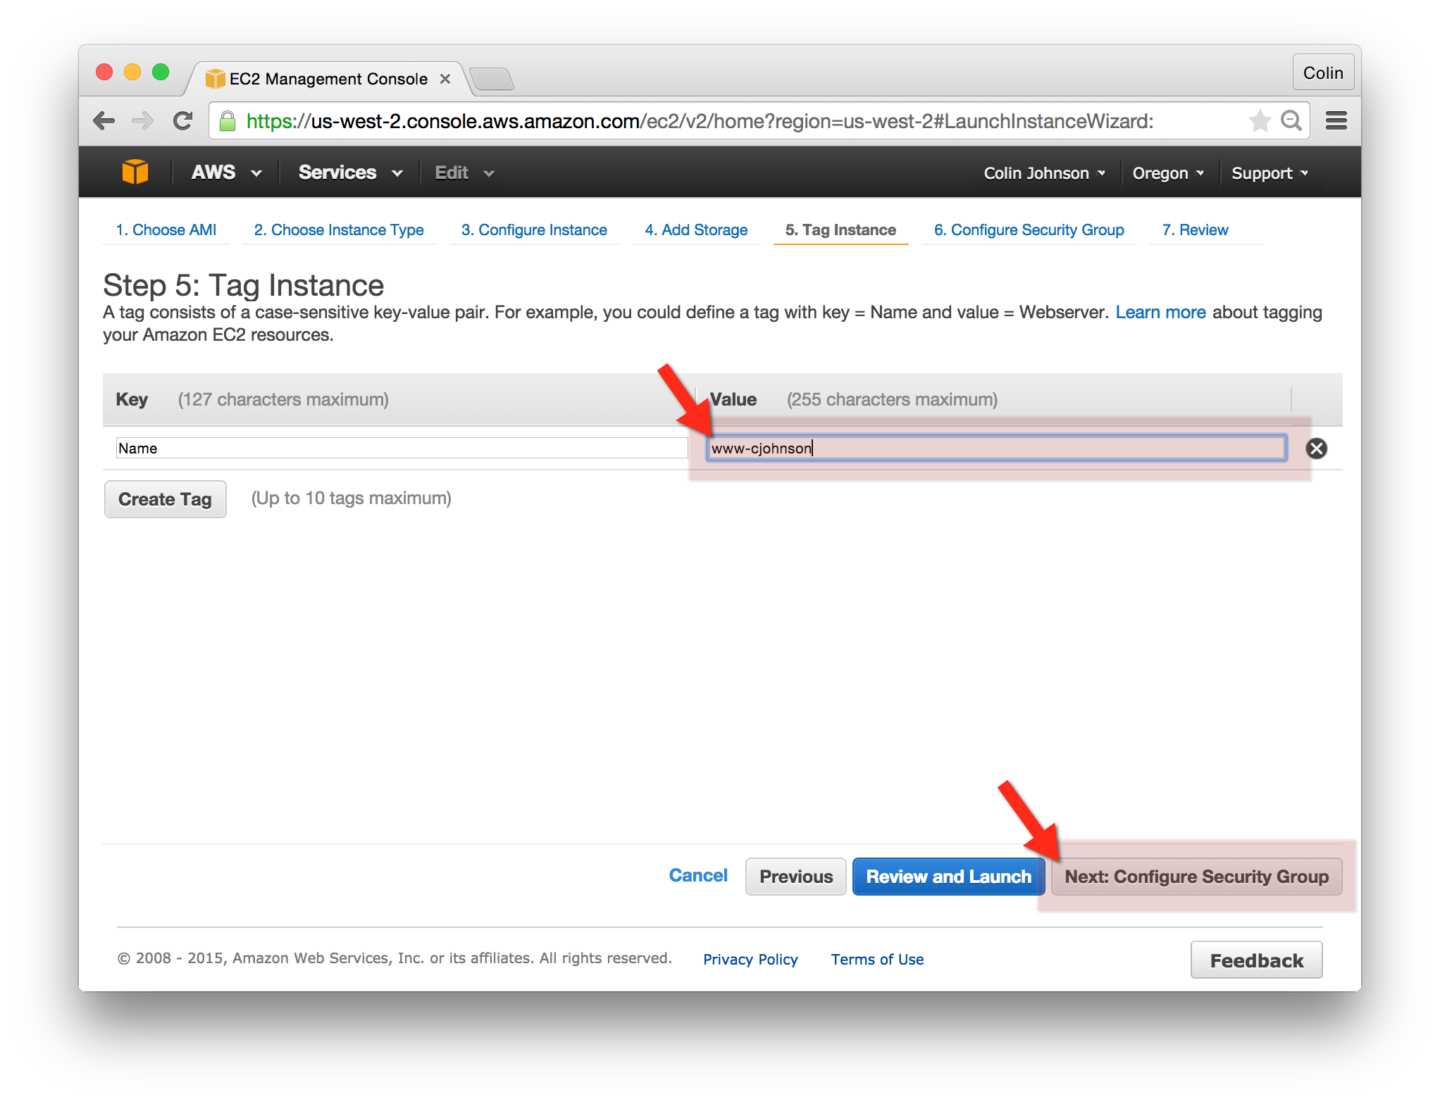

## Configure Security Group:

Depending on your configuration, Security Groups may not be able to be modified in the future (if EC2-Classic you can not modify security groups, if EC2-VPC you can). Select the www-yourname Security Group and click “Review and Launch.”

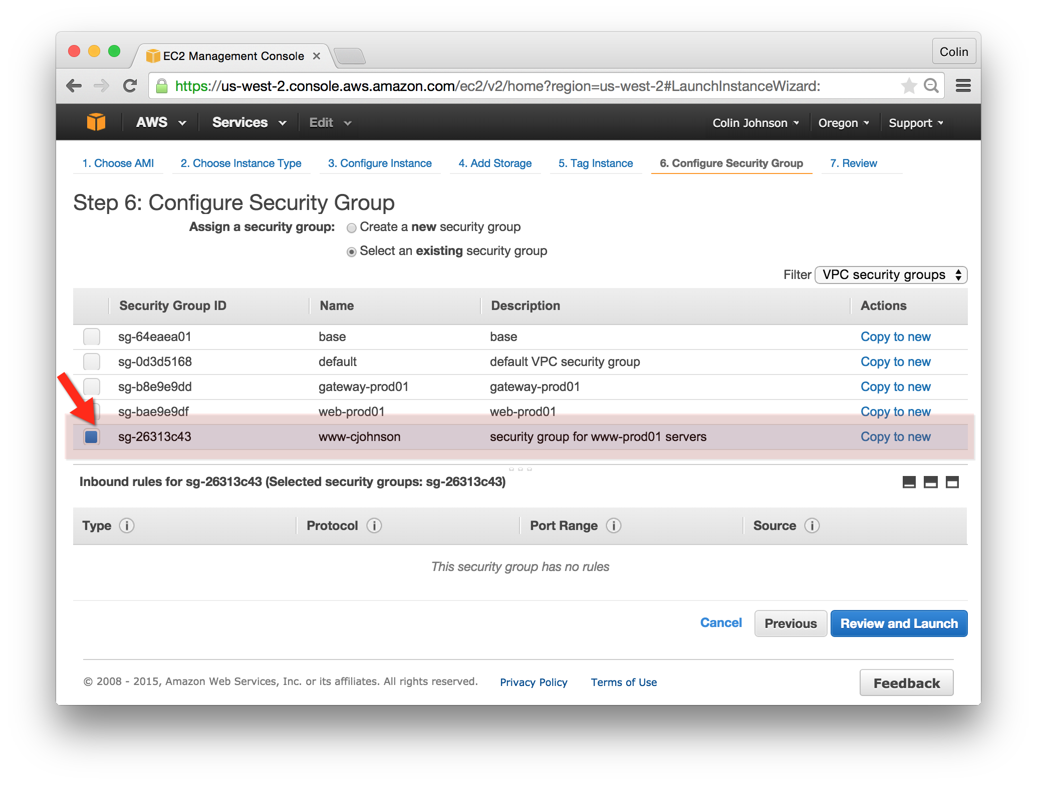

## Review and Launch:

Make sure that you are launching:

* Instance Type: t2.micro
* Security Group: www-yourname
* Instance Details -> Network and Subnet, as given by Presenter
* Assign Public IP: Enable
* Tags -> Name: www-yourname

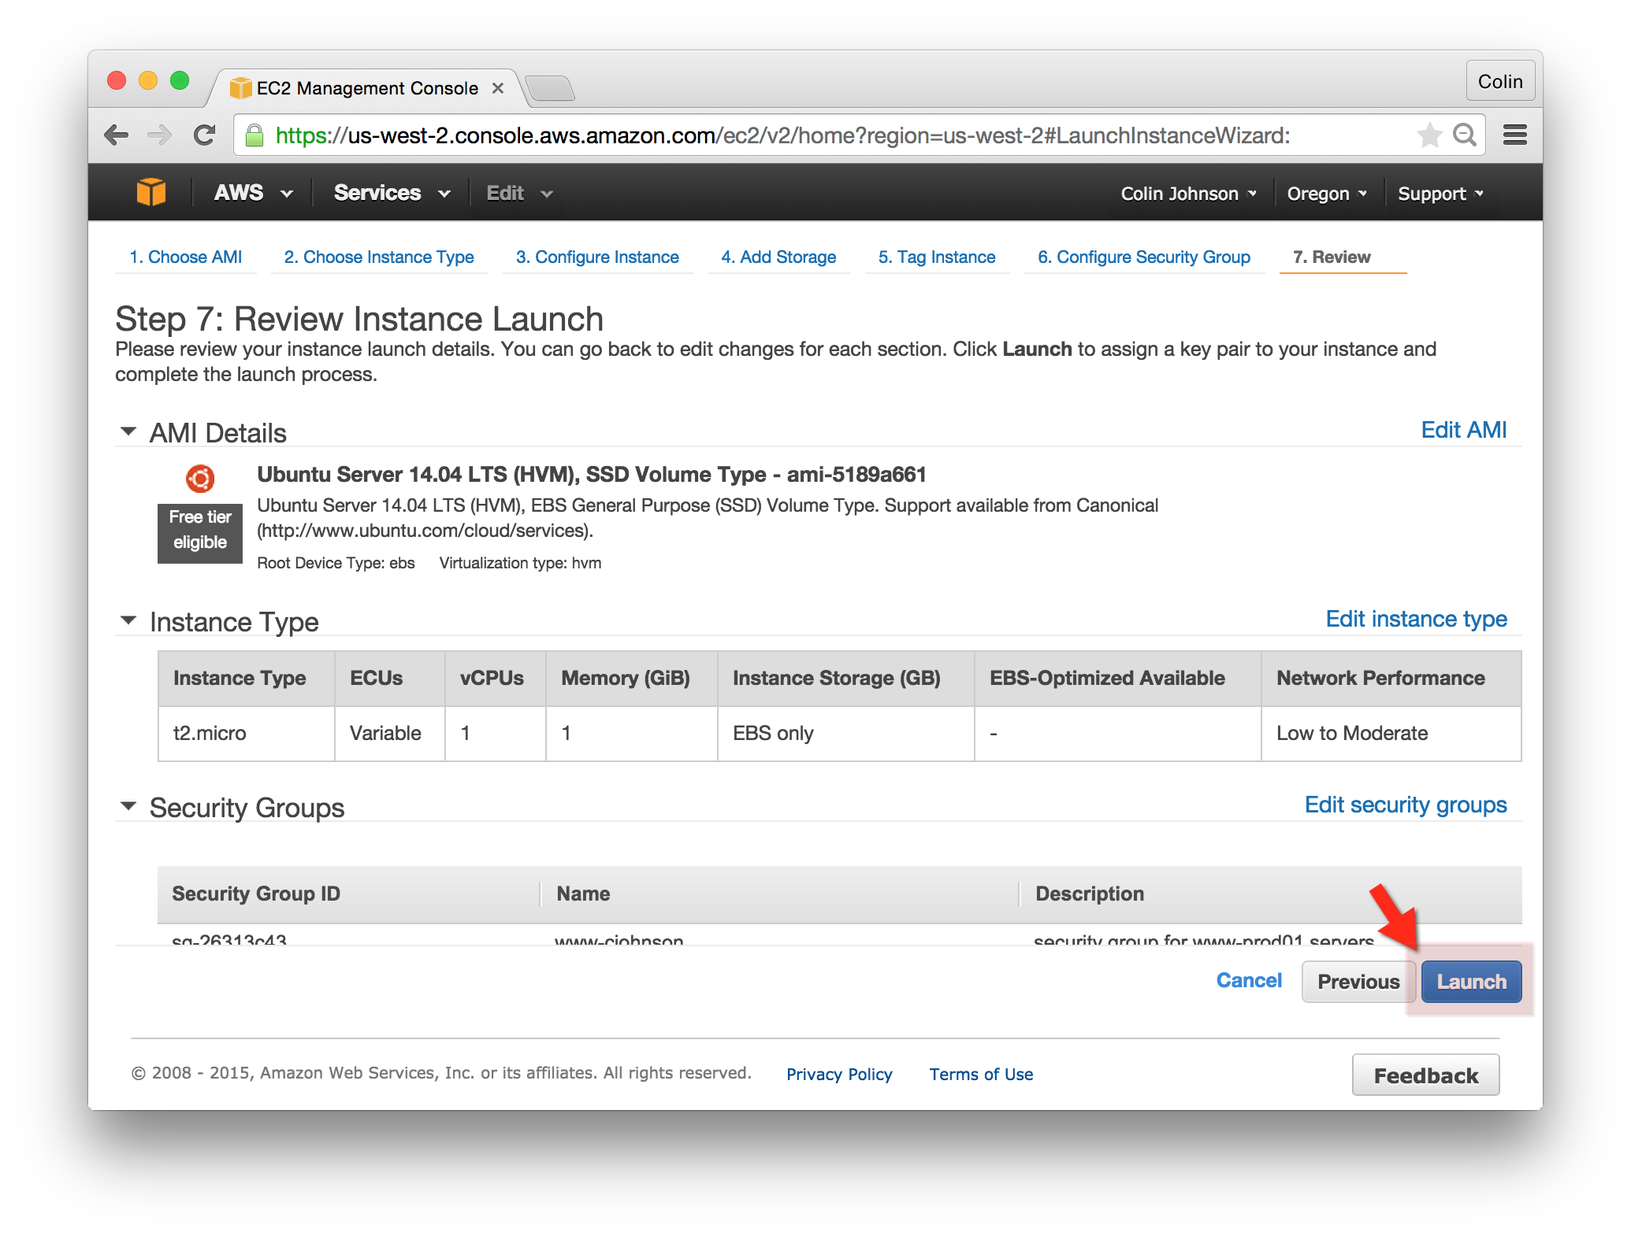

## Keypair:

The Keypair will be used to login to an instance. Create a new keypair “yourname”, click “Download Keypair” and press “Launch Instances”!

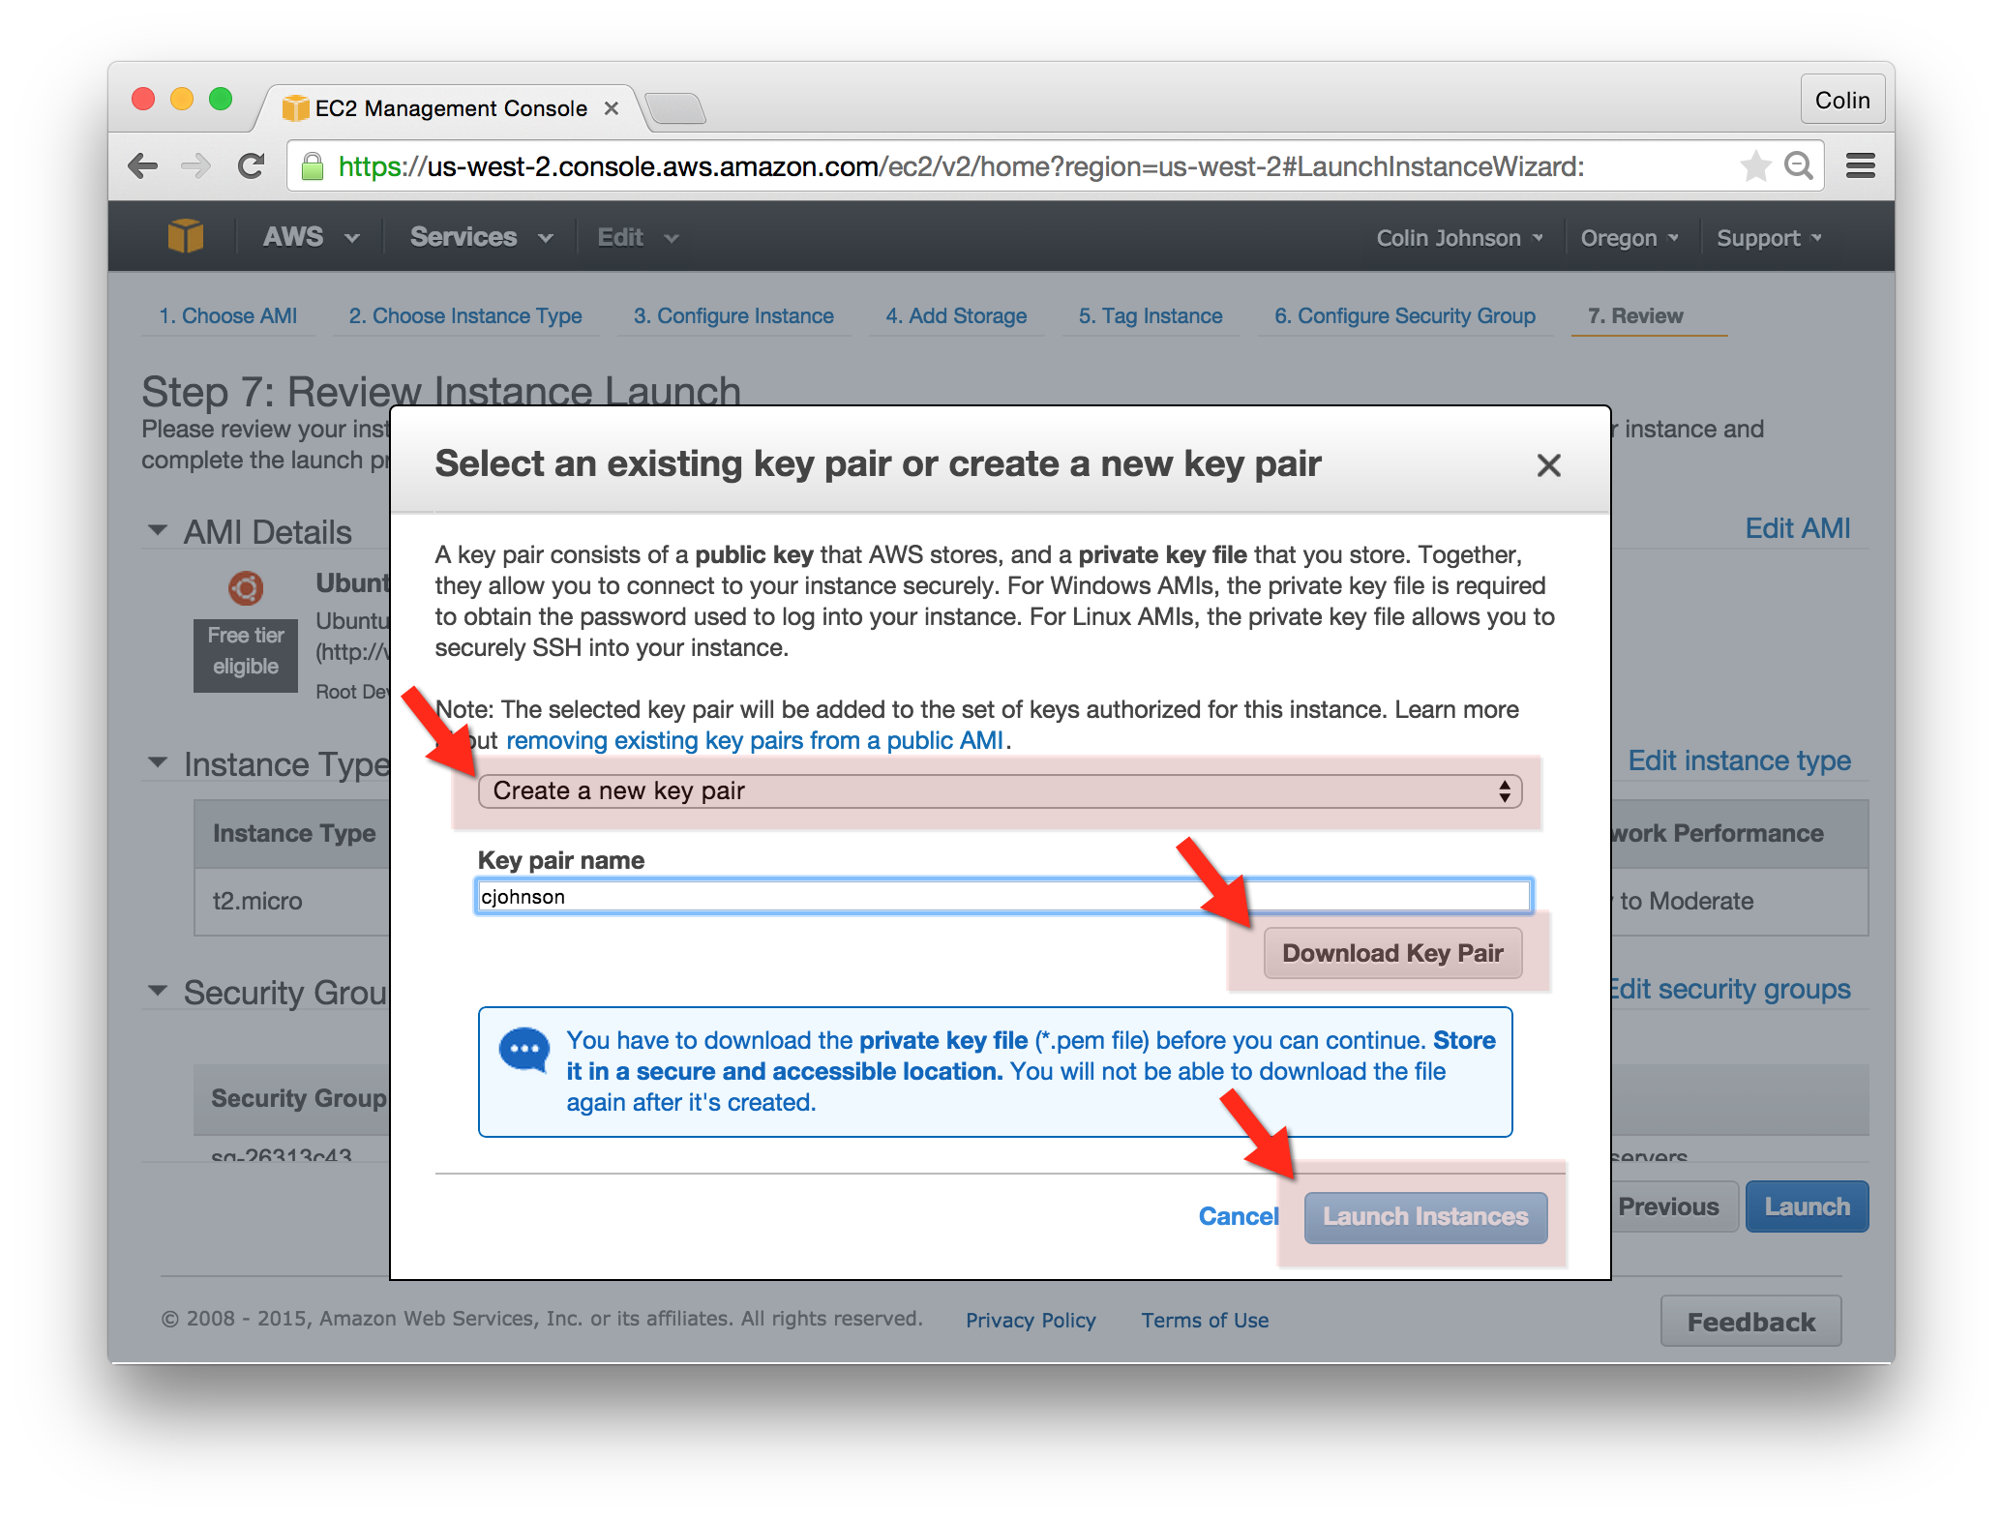

## Launch Status:

You’ll see a note that “Your instances are now launching.” You’ve created a Security Group and built an AWS EC2 Server! You’ll be ready to modify this infrastructure to serve millions of requests soon enough.